~Wide Area Networks:
- Draw a simple diagram (on paper or using an online tool like draw.io) showing how your phone connects to Instagram's servers from your home WiFi, including the ISP and at least two Wide Area Network (WAN) devices (like routers or switches) in the path.
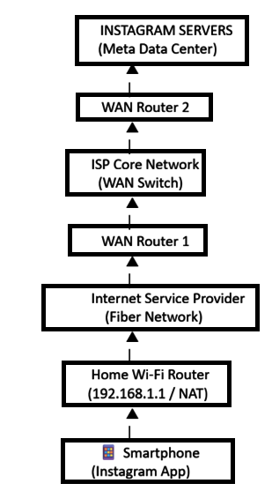
Device Labels:
- 📱 Smartphone – Connects to the home Wi-Fi.
- Home Wi-Fi Router – Provides Wi-Fi and performs NAT.
- ISP – Connects the home network to the Internet.
- WAN Router 1 – First router in the ISP backbone.
- WAN Switch – Forwards traffic within the ISP network.
- WAN Router 2 – Routes traffic toward Instagram's network.
- Instagram Servers – Process user requests and deliver content.
This diagram includes:
- ✅ Home Wi-Fi
- ✅ ISP
- ✅ Two WAN devices (WAN Router 1 and WAN Router 2)
- ✅ One WAN Switch
- ✅ Instagram servers

- Create a table listing three types of WAN technologies (such as MPLS, Leased Line, and Broadband Internet) and compare them based on speed, cost, and where you might see them used in real life (e.g., Zomato office, IRCTC ticketing, your home).

WAN Technology | Speed | Cost | Real-Life Use
MPLS | High | High | Zomato corporate office
Leased Line | Very High, Dedicated | Very High | IRCTC ticketing/data centers
Broadband Internet | Medium to High | Low | Home Wi-Fi or small office

Scenario: WAN Technologies in Real Life
- MPLS: A Zomato office uses an MPLS connection to securely connect its branches with fast and reliable communication.
- Leased Line: IRCTC uses a dedicated leased line to ensure uninterrupted and secure online ticket booking services.
- Broadband Internet: A home user uses a broadband connection for Wi-Fi to browse the internet, stream videos, and access online services.

- Research and write a short explanation of how a VPN (Virtual Private Network) uses WANs to let you access apps like Spotify or YouTube securely from a public WiFi at a coffee shop.<br><br><em><strong>Hint:</strong> Focus on how the VPN creates a private tunnel over the public WAN.</em>

VPN and WAN – Short Explanation:

-When you connect to public Wi-Fi at a coffee shop, your device uses the Wide Area Network (WAN) to access the Internet. A VPN (Virtual Private Network) creates an encrypted private tunnel between your device and the VPN server over this public WAN.

-All your data, such as when using Spotify or YouTube, travels securely through this encrypted tunnel, making it difficult for hackers or anyone on the same Wi-Fi network to intercept or read your information. This improves privacy and protects your online activity while using public networks.

- Imagine Flipkart wants to connect its warehouses in Ahmedabad, Mumbai, and Delhi. Suggest which WAN technology would be best for them and justify your answer with two reasons.
Scenario: Connecting Flipkart Warehouses Using a WAN
Company: Flipkart
Locations: Ahmedabad, Mumbai, and Delhi
Recommended WAN Technology: MPLS (Multiprotocol Label Switching)
Justification:
- Secure Communication:
MPLS creates a private network between all warehouses, allowing inventory, customer orders, and payment information to be transferred securely without relying solely on the public Internet.
- High Performance and Reliability:
MPLS provides low latency, minimal packet loss, and consistent bandwidth. This ensures that warehouse management systems, inventory updates, and order tracking work smoothly in real time.
- Easy Branch Connectivity:
MPLS can connect multiple warehouse locations into a single network, making it easier for employees to share data and access central servers.
- Better Quality of Service (QoS):
Important business applications, such as order processing and inventory management, can be prioritized over less critical traffic, ensuring faster response times.
Conclusion:
For a company like Flipkart, which operates warehouses in Ahmedabad, Mumbai, and Delhi, MPLS is the most suitable WAN technology because it offers secure communication, reliable performance, centralized connectivity, and efficient data transfer, helping the company manage orders and inventory across all locations.

THE END……

